# CS 255 System Design Document Template

This template lays out all the different sections that you need to complete for Project Two. Each section has guidance to prompt your thinking. You will need to continually reference the interview transcript as you work to make sure that you are addressing your client’s needs. There is no required length for the final document. Instead the goal is to complete each section based on what your client’s needs are. Remove this note when you are finished, and replace all bracketed text with the relevant information.

## UML Diagrams

### UML Use Case Diagram

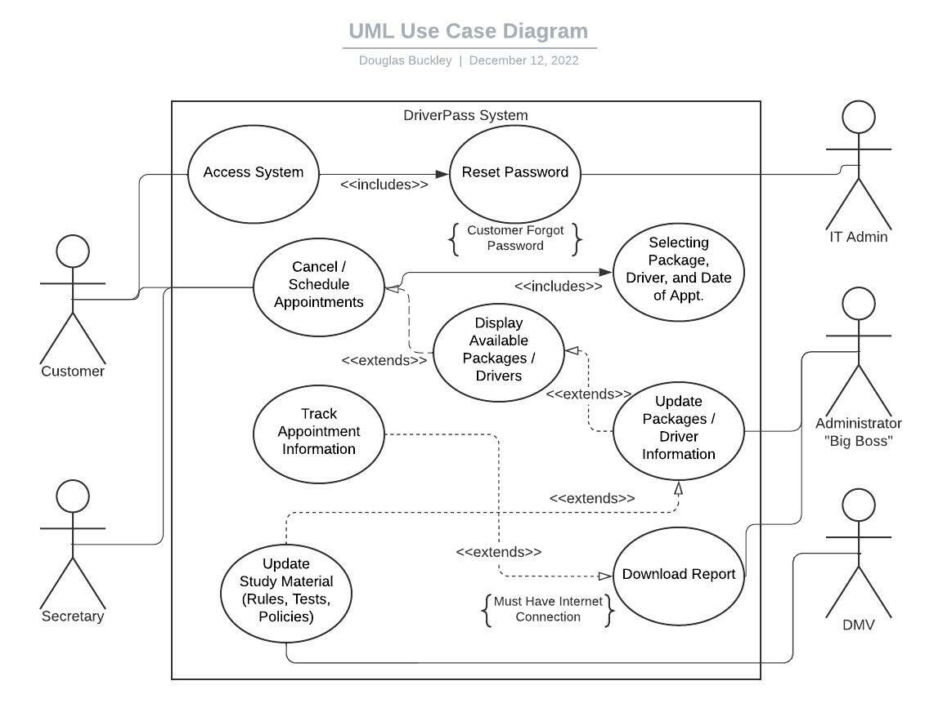

### UML Activity Diagrams

### UML Sequence Diagram

*[You were asked to create a sequence diagram based on* ***one*** *of the use cases you chose. Please insert your sequence diagram here. Check to make sure that you included appropriate components and symbols and that your design meets the client’s needs.]*

### UML Class Diagram

*[You were asked to create a class diagram based on the different classes and attributes needed for your system design. You are* ***not*** *required to include methods, but you may if you wish. Please insert your class diagram here. Check to make sure that you included appropriate components and symbols and that your design meets the client’s requirements.]*

## Technical Requirements

*[Based on the diagrams you have created, describe the technical requirements of your system. These requirements should address the required hardware, software, tools, and infrastructure necessary for your system design.]*

* Company will need to have cloud based server service to be able to host the system on it
* Company will need to ensure system can be accessed by all major operating systems (Windows, MacOS, Linux) as well as mobile devices (Android, IOS)
* System will have to be able to perform in low-bandwidth conditions
* User will need either a machine with a major operating system or mobile device capable of internet access
* Cipher algorithms are recommended to hash sensitive user-data and passwords
* Monetary vendors such as PayPal, Samsung Pay, or Apple Pay should be able to complete purchases with the system
* System will need to maintain connection with DMV servers to be able to stay up to date with tests and regulations.